**Universal Search**

1. **Question:**

In original specification, nothing is specified that login is required by user to use universal search functionality not?

**Assumption:**

According to entity specification I understand that to access or create any of entity user must have to logged in. Because these all entities would be private to team or individual. So, I will have to create functionality that uses only user data to show result.

Please confirm that my assumption is correct or not and provide some additional information about the same.

1. **Question:**

As per mentioned in specification,

There are different entities to deal with. Now when user searches for something, generated result from all entities would be display in single page? Or entity wise categories the result and display to user with different tabs?

**Assumption:**

As per my understanding, display result within single page would may cause difficulty to user to find out which entity contains that result. So, if result would be distinguished according to entity it would be easy to user to go through all the details in easy manner.

Please confirm that my assumption is correct or not.

1. **Question:**

In original specification, nothing is specified about suggestion. Should system suggest other keywords related to the searched keyword?

**Assumption:**

As per my understanding, most of the time user will not search exact words. So, it would be good if system will provide suggestions to get clear idea about what he is finding.

Please confirm it.

1. **Question:**

As per mentioned in specification,

Job could be in team or individual. Should system generate the search results from all the team members content also or user will be able to search the keyword only within his area of access?

**Assumption:**

I have assumed that job is done in team. So, search result should provide information from team members who has contribute in job by adding Data entered, Assets, Images, Audio, Video etc.

1. **Question:**

If auto suggestion is there, then what would be the limit for keyword suggestion.

**Assumption:**

As per my knowledge, for fast response suggestion much limits up to 10 results.

Please confirm that my assumption is correct or not.

1. **Question:**

When search result would be display, Will system provide the link to the specific entity at which keyword is belongs to. Or it will display only the content at which it is belongs to?

**Assumption:**

I have assumed that result should provide link to which keyword is belongs to. It will allow the user to move faster to the content that he want.

Please confirm that my assumption is correct or not.

**Mockups:**

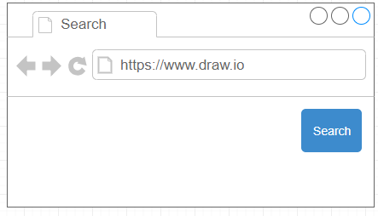

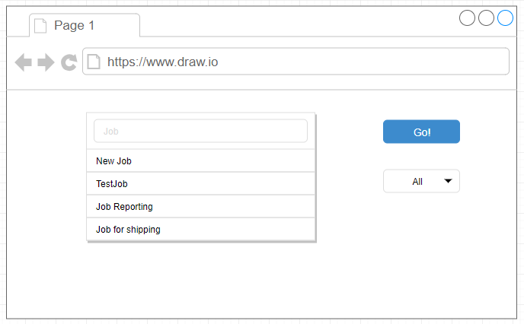

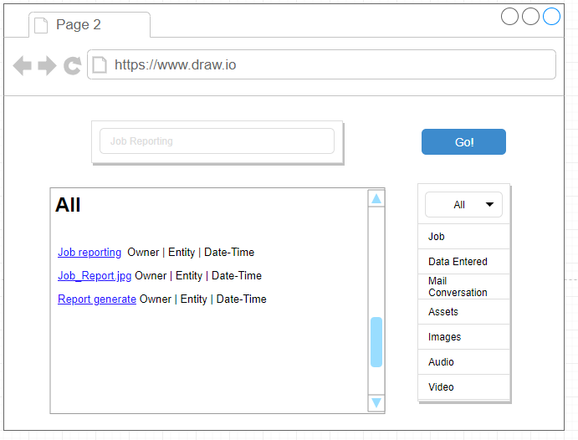

**Estimation:**

|  |  |  |  |  |
| --- | --- | --- | --- | --- |
| **Feature** | **Activities** | **Spent Hours** | **Estimation Hours** | **Total Hours** |
| **#** Search Functionality in existing system.  After successful login, User would be able to search anything that is exists in its space.  When user searches for any keyword in search bar, system will display results according to his selection criteria from the drop-down list (I.e. All, Job, Data entered, Mail conversation, Image, Audio, Video)  Result would be display in form of links pointing to the actual content. | Analysis | 96 | 100 | 96 |
| Development  - Regular Development  - Code Review Process  - Bug Fixing | 168  104  85 | 170  100  80 | 357 |
| Design | 80 | 90 | 80 |
| QA Testing | 160 | 145 | 160 |
| Deployment | 145 | 160 | 145 |
| **Total Hours:** | | 838 | 845 | 838 |